CURRICULUM VITAE

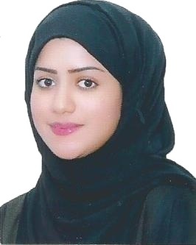
Name Marwa Ahmed Hasen Hubail
Nationality Bahraini
Address house 17- Road 801- block 608 – Sitra
Phone +973 33624426 - +973 33782425
Email marwaali.92@outlook.com
CPR 921201265

Education *
2010 Sitra Secondary School

Secondary Certificate
Commercial Studies

2015 University of Bahrain
College of Business Administration
Bachelor of Science in Accounting
Overall GPA: 3.12 out of 4.0
Experience*
2009 Community service program in sitra

2015 Internal Audit (Deloitte & Touche…)
Internship two months

2016 Hussain Ismail Trade Center
( ACCOUNTANT ) Sept 2016 to May 2017
• Preparing Journals, and cheque payment vouchers
• Preparation of Payment vouchers.
• Balance cash and receipts; prepare deposits.
• Perform a variety of general clerical duties including typing, maintaining files and records, and processing the mail.

Al fares Food Packing Factory 2017
( ACCOUNTANT) June 2017 to May 2019

- Preparing Journals, and cheque payment vouchers.
- Preparation of Payment vouchers.
- Monitor and reconcile petty cash fund.
- Balance cash and receipts; prepare deposits.
- Making invoices .
• Perform a variety of general clerical duties including typing, maintaining files and records, and processing the mail.
-
• Enter updated information into the database.
• Input documents into computerized accounting program.
Hobbies *

Reading
Watch TV

Skills *
Good communication skills
Computer skills
Fast understand

Language *
Arabic (native)
English (very good)

